**Listening comprehension activities in the teaching-learning process of the English language**

**Actividades de comprensión auditiva en el proceso de enseñanza-aprendizaje del idioma inglés**

Cristhian Bladimir Alcivar Zambrano(1)

Julissa Maricela Loor Moreira(2)

Raisa Macias Sera(3)

(1) Universidad Laica “Eloy Alfaro” de Manabí, Extensión Chone, Ecuador.

[e1313436998@live.uleam.edu.ec](mailto:e1313436998@live.uleam.edu.ec) ORCID: <https://orcid.org/0009-0002-7913-3123>

(2) Universidad Laica “Eloy Alfaro” de Manabí, Extensión Chone, Ecuador.

[e1317541298@live.uleam.edu.ec](mailto:e1317541298@live.uleam.edu.ec) ORCID: <https://orcid.org/0009-0009-5992-376X>

(3) Universidad Laica “Eloy Alfaro” de Manabí, Extensión Chone, Ecuador.

[raisa.macias@uleam.edu.ec](mailto:raisa.macias@uleam.edu.ec) ORCID: <https://orcid.org/0000-0001-9618-2854>

Contacto: [raisa.macias@uleam.edu.ec](mailto:raisa.macias@uleam.edu.ec)

Artículo recibido el 03/junio/2024. Aprobado 06/junio/2024

**Abstract**

The objective of this article is the elaboration of activities, to favor the development of listening comprehension in the teaching-learning process of students who showed insufficiencies in the listening comprehension of the English language at the "Cinco de Mayo" Fiscomisional Educational Institution. It is a field-action research and research methods such as analysis-synthesis and inductive-deductive method with mixed approach were used to determine the students' listening comprehension level and the elaboration of the proposal. The instruments used were: classroom observation cards and diagnostic test applied to the students to determine the level of listening comprehension in English, interview with English teachers to learn about the information they have about the current practices of teaching listening comprehension. The population consisted of 214 students. The sample consisted of 63 eighth grade students and 4 English teachers. The analysis of the results indicated that the activities used are insufficient to develop listening comprehension and that the proposal contributes to its development by approaching it from a set of activities focused on the integral development of listening comprehension, considering the students' ability levels.

**Key words:** Listening comprehension, teaching-learning process, activities, English language.

**Resumen**

El presente articulo tiene como objetivo la elaboración de actividades, para favorecer el desarrollo de la comprensión auditiva en el proceso de enseñanza-aprendizaje de los estudiantes que mostraron insuficiencias en la comprensión auditiva del idioma inglés de la Unidad Educativa Fiscomisional “Cinco de Mayo ". Es una investigación de campo-acción y se utilizaron métodos de investigación como el análisis-síntesis y el método inductivo-deductivo con enfoque mixto para determinar el nivel de comprensión auditiva de los estudiantes y la elaboración de la propuesta. Los instrumentos utilizados fueron: fichas de observación a clase y prueba diagnóstica aplicada a el alumnado, para determinar el nivel de competencia auditiva en ingles, entrevista a los docentes, para conocer sobre la informacion que tienen acerca de las practicas actuales de la enseñanza de la comprensión auditiva. La población estuvo constituida por 214 estudiantes. La muestra tomada fue de 63 estudiantes del octavo de EGB y de 4 docentes de inglés. El análisis de los resultados indicó que las actividades utilizadas son insuficientes para desarrollar la comprensión auditiva y que la propuesta contribuye a su desarrollo al abordarla desde un conjunto de actividades enfocadas desde el desarrollo integral de la comprensión auditiva, considerando los niveles de habilidad de los estudiantes.

**Palabras claves:** Comprensión auditiva, proceso de enseñanza-aprendizaje, actividades, idioma inglés.

**Introduction**

English, recognized worldwide as the universal language, plays a crucial role in communication. Given its importance in the world, the ability to understand and communicate in spoken English opens up a world of opportunities in both academic and personal contexts.

In the teaching-learning process of the English language; listening comprehension skills, in particular, play a fundamental role in enabling students not only to understand the linguistic richness of English in its spoken form, but also to develop a deep understanding of the cultural and social complexities associated with this language. In addition, the focus on developing listening comprehension not only improves students' oral fluency, but also fosters their ability to participate effectively in cross-cultural problem solving.

Several authors define listening comprehension from different perspectives: Pourhosein Gilakjani & Narjes Banou Sabouri (2016) define listening comprehension as the ability in which listeners understand spoken input through discrimination of sounds, prior knowledge, grammatical structures, accentuation and intonation, and other linguistic or non-linguistic cues. The authors emphasize that listening comprehension is a complex skill that involves a number of factors beyond linguistic aspects. The listener's attitude and perspective are crucial to interpreting spoken discourse effectively. Therefore, listening comprehension benefits from active listening, as it involves active engagement in the interpretation of the message.

Similarly, Tran, T. Q., & Duong, T. M. (2020) define listening comprehension as "A complex process in which students need to exert both their language knowledge (i.e. vocabulary, sounds, and grammar) and background knowledge to comprehend what is spoken." (p. 79-80). Listening comprehension is not simply hearing sounds; it is an active and dynamic mental activity that requires integrating multiple skills. Students must use their understanding of words (vocabulary), how sounds are organized (phonology), and how words combine to form meaningful sentences (grammar).

On the other hand, in the field of English language teaching and learning, listening skills are often underestimated in comparison to the others. However, Jyoti, R. (2020) suggests that listening is an invisible mental process and that among the four language skills, listening, speaking, reading and writing, listening is considered the most important skill in the field of English language teaching and learning since it is the most used language skill in daily life.

Ecuador is one of the Latin American countries with the highest deficiency in English proficiency. According to the EF EPI English Proficiency Index, 2021. The country has a score of 440 out of 1000, which is equivalent to an A1 level, considered basic. Some of the factors contributing to this situation include the low level of teaching in the country, the lack of student motivation, and the scarcity of adequate technological resources for teaching and learning English.

In Ecuador, analyses and surveys have been carried out in all the schools of the different provinces and it has been proven that a great majority of them do not present great progress in the listening comprehension of the foreign language. It has been observed that when students have conversations in English with their classmates, they understand only 40% of what the other person says (Machado Falconi, E. F., & Quel Rosero, R. F. 2014, p.2).

This shows that English language learning in Ecuador, specifically listening comprehension in upper elementary school is greatly affected since students do not understand the instructions in English that the teacher gives and do not reinforce their words with gestures or mimics and this in turn generates disinterest on their part in learning.

During the pre-professional practice carried out at the "Cinco de Mayo" fiscomisional Educational Institution, it was observed insufficient motivation, comprehension to perform the activities of auditory competence on the part of the students and lack of strategies to generate interest in the students on the part of the teacher; for this reason it was considered to apply a diagnostic test that consisted of a set of listening questions where it was obtained as expected results the lack of understanding in the vocabulary of the text, deficiencies in the understanding of the grammatical structure and the main idea of the audio, among others.

The aforementioned allowed us to establish the following scientific question: How to design activities to favor the teaching of listening comprehension in English in high school students? The objective of this research was to elaborate a set of activities, supported by a set of tasks, to favor the teaching of listening comprehension in English in high school students.

The population was constituted by 214 students of the "Cinco de Mayo" fiscomisional Educational Unit. The sample taken was of sixty-three students in the eighth grade of EGB.

**Literature Review**

Human listening comprehension involves important processes in language acquisition and communication in different situations. Understanding how these processes work is essential for second language teaching. According to Antich (1986), these processes are:

* Perception of linguistic signs as a result of hearing.
* Identification of what is heard with the known reference pattern.
* Decoding of the linguistic sign.
* Establishment of relationships between concepts based on their grammatical form.
* Comprehension of the content of the utterance.
* Self-control.

Listening comprehension is a complex process involving several interconnected steps. Understanding these processes is essential for second language instruction, as it provides a solid basis for developing effective pedagogical strategies to help learners improve their listening comprehension in a new language.

English listening comprehension is a complex process that involves several brain mechanisms involved in auditory processing, as expressed by Neurosciences (n.d.), these are: sound coding, pattern recognition, auditory memory, spatial localization and auditory integration. It is important to understand these brain mechanisms in order to develop strategies to improve listening comprehension, identify and diagnose difficulties in auditory processing, by understanding the brain mechanisms involved in English language comprehension, we can improve communication and social participation of students. This process is essential for identifying words and phrases. The brain receives information from the ear and transforms it into electrical signals that it interprets as specific sounds. Deficiencies in any of these mechanisms can affect the ability to learn, understand and use the English language effectively.

Listening comprehension is involved in almost all daily activities, which is why it is transcendental for the development of a true communicative competence; but in the particular case of learning a foreign language there are few opportunities to practice this skill outside the classroom, simply because the foreign language is not the main means of communication in the student's natural environment (Arévalo, 2019, p 7).

Listening comprehension is crucial in foreign language teaching to develop communicative competence. However, it is challenging, as the foreign language is rarely used in the learner's daily life. This highlights the need for effective strategies to promote listening comprehension in the classroom and beyond.

English listening comprehension is essential for elementary students as it enables them to understand and communicate effectively in real-world situations. It is essential to provide them with activities that develop this skill, such as podcasts and videos in English, class participation, audio books, as well as providing them with opportunities to practice active listening and answer questions about what they have heard.

"When choosing didactic activities, it should be considered that they are interesting and motivating material for students and increase the effectiveness of listening comprehension in the teaching-learning process" (Córdoba et al., 2005). In fact, different aspects to consider when choosing didactic activities can be distinguished, such as:

Relevance of the Material: it is important that the material to be selected be pertinent and relevant to the students. This implies considering their interests, level of competence and cultural context. By using content that is meaningful to them, their intrinsic motivation to actively participate in the activities is fostered.

Variety and Diversity: Diversity of learning activities is essential. Not all activities should be the same; it is beneficial to include a variety of approaches (such as games, discussions, projects, etc.) to maintain students' interest and attention throughout the learning process.

Incorporation of Technology and Current Resources: Consideration should be given to the integration of technology and multimedia resources. For example, the use of authentic videos, podcasts or interactive platforms can enrich the listening experience and make it more engaging for students.

Contextualization: Contextualizing activities within real-world or relevant situations also increases motivation. For example, simulating a job interview or phone call provides an authentic context for listening practice.

Creativity and flexibility: It is important for teachers to be creative and flexible when designing classroom activities. Sometimes even small changes can make an activity more interesting and engaging for students.

In order to know how listening comprehension is developed, it is necessary to know how different authors approach listening comprehension activities. González, A. A., Molina, D. M., & Enríquez, A. C. (2020) point out that: "In today's technological era, it is much more difficult to capture and maintain students' attention. It is difficult to get our students to engage in active listening while we teach, so listening strategies have changed." This implies that traditional approaches to teaching listening comprehension may require adaptations, as students may have difficulty engaging in active listening. Therefore, it is essential that educators adopt innovative strategies that align with the needs and realities of student attention in today's technological environment.

On the other hand, Peris, E. M. (2007) mentions that in the context of teaching listening comprehension it is crucial to verify the existence of prior knowledge among students before carrying out classroom exercises. Even in situations where it is believed that students possess prior knowledge, it is recommended to update their comprehension through activities designed for this purpose. In addition, comprehension can be fostered by posing questions and proposing activities that encourage learners to make connections between their existing knowledge and newly presented concepts.

Cocha (2017) in his undergraduate degree work shows that "the use of resources that motivate this development depends largely on the teacher, therefore, the type of activities will influence the student's confidence and willingness to perform them as these are always aimed at strengthening the development of listening skills" (p.56). In the same way, Asencio (2022) suggests that pronunciation, speed of speech, idioms, grammar and phrasal verbs are important elements that affect the comprehension of a listening track in English and that podcasts are a very good idea as an alternative to practice and significantly improve students' listening skills.

On the other hand, Abreus, Martínes & Castiñeira (2020) show favorable results in the development of the skill from the diagnostic phase to the application phase of the proposal; in addition, it is concluded that the teaching-learning process of listening comprehension was facilitated with new activities that were more meaningful for the students, who felt better motivated by the contact with the English language.

**Methodology**

The methodology is a field-action research and methods such as analysis-synthesis and inductive-deductive method with mixed approach were used to determine the students' listening comprehension level and the elaboration of the activities.

The population consisted of 214 students of the "Cinco de Mayo" fiscomisional Educational Unit. The sample was made up of sixty-three eighth grade EGB students and four English teachers who were selected based on a convenience sampling approach, based on their availability and willingness to participate in the research.

The instruments used were the observation sheet to determine student behavior and teacher strategies such as audiovisual material, encouraging active listening, using the context to understand and working with specific vocabulary. In addition, a diagnostic test to evaluate the students' listening competence, and finally, an interview with teachers whose objective was to understand the current practices of teaching listening comprehension in students of the Unidad Educativa Fiscomisional "Cinco de Mayo" in Chone.

The set of activities that were proposed as part of this research proposal helps the full development of listening comprehension and the teaching-learning process of the English language.

**Results**

**Classroom observation**

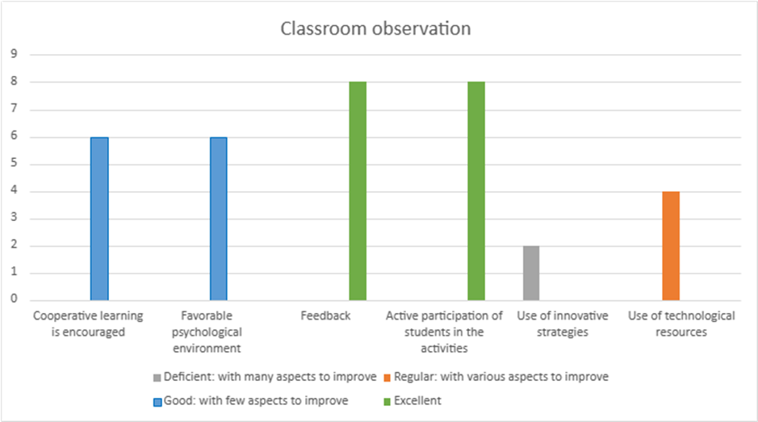

Figure 1. Classroom observation of the teacher

The objectives established by the teacher for the eighth grade students were aligned and appropriate according to the content of the activities, in addition to being presented in a logical order that facilitates learning.

The number of students is 30, which allows the teacher to explain terms, concepts and the meaning of new words effectively. The audio quality was adequate, which is essential for listening comprehension activities. However, the material selected for the listening activity did not match the students' interests, as the subject matter of the short story failed to adequately motivate them. It is crucial for the teacher to consider the students' interests when selecting texts to encourage greater participation and enthusiasm.

The explanations provided by the teacher were varied and adapted to complex materials, which is positive. It is important to highlight that the combination of skills, such as listening with other activities, is crucial in the teaching and learning process.

The first graph shows a good performance of the teacher in the active and cooperative learning aspect (figure 1). Small group work, where students filled in blanks after listening to the text, enhanced cooperative work in the classroom. An improvement is also observed in the facilitation of questions by the students and in the presentation of appropriate material.

Although the teacher has mastered the content, interaction with students is not always adequate. Therefore, she needs to improve her communication and adapt to the needs and levels of the students. In addition, she should make better use of the whiteboard or screen to highlight important concepts and facilitate class follow-up.

It was not observed that the teacher asked questions at the end of the class to verify understanding of the activities, nor did she review the class objectives at the conclusion of the session. This is essential to create more opportunities for students to express their doubts and to ensure that the material used is relevant and accessible, catering to different learning styles.

The strategy used by the teacher in the listening class was traditional, the use of technological resources was not optimized since only the text was listened to and the questions were answered. Nonetheless, the students responded to the activities proposed in the class.

**Interview with teachers**

100% of the teachers agree that listening comprehension is very important in the teaching-learning process of the English language because it allows students not only to identify sounds, rhythms, words, but also to learn vocabulary through it. In addition, teachers consider that motivation is crucial in the teaching-learning process because it facilitates the development of oral communication. Likewise, the teachers selected as the most relevant for the elaboration of listening material and in that order of importance: the level of linguistic competence, age, motivation, quality of the listening material, the topic and pronunciation of the student. In addition, 75% of the teachers are guided in selecting and adapting listening material by the book or on the basis of the topic to be covered in the class.

On the other hand, the most successful listening comprehension activities used by the teachers interviewed were: podcasts, digital platforms and songs. In the same way, teachers state that technology plays a very important role in the teaching of listening comprehension in the institution because children are more motivated and consider it fundamental that technology and languages work together.

Among the most common challenges teachers face when teaching listening comprehension are the following: the speed of speech, students who do not like the subject, pronunciation, and lack of student interest. In addition, teachers evaluate the effectiveness of their methods and activities in the teaching-learning process in different ways, such as: questions during the activity, feedback, a purely oral production at the end of each term, and evaluation at the end of each midterm. Finally, some of the recommendations and teaching tips were as follows: it is recommended that teachers engage in daily practice to find a way to encourage students to use the language not only in the classroom but also outside. It is also recommended that teachers do not limit themselves to planning, but rather, that they have a good command of the language and that they are constantly learning it.

**Student Diagnosis**

For the diagnostic test applied to the students (figure 2), an appropriate text was used in a listening exercise where the students answered 8 multiple-choice questions about the text they had listened to. The scoring rubric included 4 aspects: specific details of the text, understanding of the vocabulary, understanding of the grammatical structure and understanding of the main idea of the text, focusing on listening comprehension of the English language with a score of 8 points to a sample of 63 students.

Each of the aspects contains a score, excellent was (7-8) points, in good for students who scored (5-6) points, fair for students who scored between (3-4) points, and finally poor (1-2) points.

14.28% of the students demonstrated excellent listening comprehension, considering that they should understand details and specific aspects of the text, such as sentences and words, in addition to showing a deep and complete understanding of the auditory material. Achieving a score of 7-8 points.

Then 15.87% of the students reached a good level of auditory discrimination, which shows that they have a good level of listening comprehension, but they could improve in some aspects such as understanding the vocabulary of the text. Achieving a score of 5-6 points.

Conversely, 57.15% of the students demonstrated a regular level of auditory interpretation, indicating that they exhibited a basic understanding of auditory comprehension, with deficiencies in the comprehension of grammatical structure and vocabulary. Their scores ranged from 3 to 4 points.

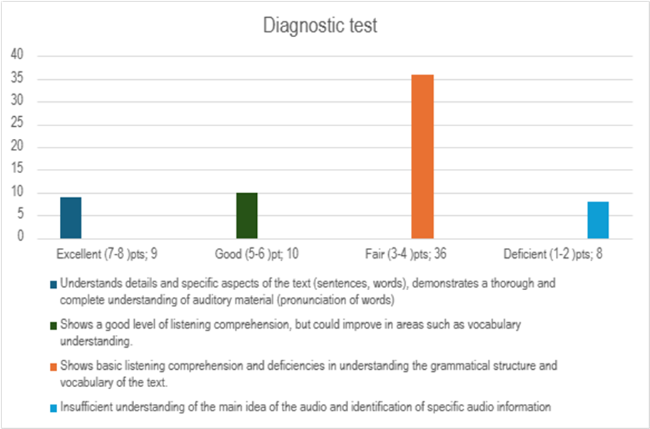

Figure 2. Diagnostic test for students

Finally, 12.70% of the students demonstrated a deficiency in their ability to comprehend the main idea of the audio and to identify specific elements within it. This was evidenced by their obtaining a score of 1-2 points.

**Activities supported by a set of tasks, to favor the teaching of listening comprehension in English to high school students.**

The proposal offers a set of activities designed to address the specific areas of difficulty identified in the diagnostic test applied to the students (understanding of the vocabulary of the text and comprehension of its grammatical structure, and understanding of the main idea of the audio). These activities are based on tasks that promote the comprehensive development of listening comprehension, considering the different levels of ability of the students.

Each activity and task has been selected and designed to provide a rich and diverse learning experience that enhances listening comprehension and motivates students to engage in their learning. The adaptability of these activities and tasks allows for their application in a variety of educational contexts and with students of different levels of English proficiency.

For students demonstrating an exemplary level of proficiency (7-8 points):

* **Debate:** The English teacher proposes a debate on the topic of "video games as an educational tool in schools." Students are expected to listen carefully to the arguments of both sides, take notes on key points, relevant vocabulary, and useful expressions, and finally, participate in a subsequent discussion to express their own opinion on the topic.
* **Speech Analysis:** In this exercise, students analyze Malala Yousafzai's speech on the importance of education for girls. They then compose a brief essay or paragraph expressing their own views on this topic. To complete the task, they are instructed to identify key arguments and specific vocabulary pertaining to both education and human rights.

For students with a proficient level (5-6 points):

* **Role Play:** The teacher poses a simulation in which one of the students is a new tourist in the city of Chone and needs to book a hotel near the land terminal.

Roles to assume:

* 1. Customer (explains the type of room he/she is looking for, dates of stay and any other requirements).
  2. Hotel clerk (provides information about available rooms, prices and services).
* **Contextualized Vocabulary Exercises:** Hotel vocabulary in English. Listen to the audio describing the check-in process at a hotel trying to identify and understand the vocabulary related to hotels. After listening, write down the hotel-related words you recognized. Share your lists in small groups and discuss the meaning of each term.
* For students with regular level (3-4 points):
* **Comprehension of Instructions:** The teacher assigns the activity of listening carefully to the audio of how to prepare an encebollado trying to understand each step and the ingredients needed. After listening to the audio, students must write the recipe step by step, including the list of ingredients and quantities.
* **Songs and Lyrics:** Play the song as many times as necessary and complete the missing words in the song (gap-fill activity). After completing the lyrics, discuss the meaning of the song with the class.
* For students who are at a deficient level (1-2 points):
* **Keyword Identification:** students should listen to a story about two friends, while listening, pay attention to words that seem important or are repeated. They write down those key words on a piece of paper and after listening, they share their words with the class and talk about why they are important.
* **Association Exercises:** Listen to an audio that describes different people, look at a series of pictures that represent what is mentioned in the audio and connect each part of the audio to the corresponding picture.

General Activities for All Levels:

* **Creative Dictation:** the teacher reads aloud the excerpt of a story, while the student listens, writes down what he hears as best he can. The student should not worry about not correctly identifying each word, but should focus on the main ideas. After the dictation, students should use their imagination to add a continuation to the text or story you have written. At the end, the student reads their creative version of the text aloud to the class or in small groups.
* **Podcasts:** Listen to the podcast carefully. Try to understand the overall message without worrying about understanding every word. Jot down key words or phrases you catch as you listen. Try to make a brief summary of what you understood from the podcast. Share your summary and key words with other students or your teacher and discuss what you learned. Listen or watch the podcast or video again to catch details you missed the first time.

**Discussion of the results**

According to the findings, it is recognized that listening comprehension activities in the English language teaching-learning process are sometimes not preferred by students, so these activities should be motivating and innovative. It was determined that teachers agree that listening comprehension is important in the teaching-learning process of the English language since it allows students not only to identify sounds, rhythms or words but also to identify new words or phrases. Likewise, motivation is crucial in the development of these activities. These results are related to Syakur's (2020) assertions, who argues that didactic activities such as dictation can significantly improve students' listening comprehension. Therefore, a reflection on the implementation of pedagogical strategies that foster a positive attitude towards listening comprehension and, in turn, enhance English language learning is proposed. Similarly, it is accepted that the most successful listening comprehension activities used by the teachers interviewed were: podcasts, digital platforms and songs. The teachers state that technology plays a very important role in the teaching of listening comprehension in the institution due to the fact that students are more motivated and they consider it fundamental that technology and Language work together so they frequently use the Padlet platform since it allows organizing audio resources (such as recordings or clips) in thematic boards to design listening comprehension activities in an interactive and collaborative way.

In addition, it is revealed that although technology is identified as a motivating factor, the observation sheet indicates that the use of technological resources was the lowest aspect in the evaluation. This highlights the opportunity to integrate more technology in teaching to improve listening comprehension. The findings suggest that instructional practices should be reviewed and updated to include more engaging and technologically advanced activities that reflect students' interests and the demands of today's world.

On the other hand, based on the findings, it is recognized that prior diagnosis of students is essential to identify their current levels of listening comprehension. The results indicate that while 30.15% of students show excellent and good ability, there is a significant proportion of 69.85% who require additional support. This underscores the need for activities that are tailored to different levels of listening ability. Activities should be designed not only to improve comprehension of vocabulary and grammatical structure, but also to foster a deeper understanding of aural content.

Finally, the set of activities is proposed as a strategy to favor the teaching of listening comprehension in English in high school students, addressing the specific areas of difficulty identified in the diagnostic test applied to the students (understanding of the vocabulary of the text and comprehension of its grammatical structure, and understanding of the main idea of the audio). These activities are supported by tasks that promote the comprehensive development of listening comprehension such as podcasting and creative dictations. These results are related to those of Suarez (2022), who suggests that podcasts can be an effective tool for improving listening comprehension skills in English by offering a variety of topics and contexts that can enrich students' learning experience. The research identifies critical factors that impact listening comprehension cues such as pronunciation, rate of speech, idioms, grammar and phrasal verbs and how English teachers can use podcasts as an alternative to improve listening skills in students. Similarly, Indahsari (2020) states that podcasts provided many advantages for learners and could attract students' interest as a digital tool for language learning due to the variety of content available. This statement is supported by the ability of podcasts to attract learners' interest as a digital tool for language learning due to the variety of content available. These tools are not only a source of authentic language material but also promote greater learner engagement and motivation, which is a crucial component of effective learning.

**Conclusions**

The literature review corroborated the critical importance of listening comprehension in the English language teaching-learning process for upper elementary students. The findings indicate that, although some students show excellent or good listening comprehension ability, there is a significant proportion who require additional support to achieve satisfactory levels of listening proficiency.

Teachers unanimously recognize the relevance of listening comprehension, not only for identifying sounds and words but also as a means of acquiring vocabulary and improving fluency in English. However, they face challenges such as lack of student interest and the need to adapt teaching strategies to current technological realities. Motivation emerges as a crucial factor in the development of listening comprehension. Teaching activities that incorporate technological elements, such as podcasts and digital platforms, have proven to be successful, suggesting that the integration of technology in English language teaching is essential to capture students' interest.

The proposal of a set of task-based activities specific to each listening skill level reflects an innovative and adaptive pedagogical approach. These activities are designed to address the difficulties identified in the diagnostic test, such as understanding vocabulary, grammatical structure, and the main idea of the audio. The need for dynamic and motivating pedagogical strategies that foster a positive attitude towards listening comprehension is crucial in the teaching-learning process. In addition, the importance of performing previous diagnostics to personalize teaching and maximize the learning potential of each student. The implementation of technology in the classroom and the adaptation of materials and activities to the interests and needs of the students are essential to improve listening comprehension and, therefore, the communicative competence of the English language.

**Bibliographic references**

Abreus González, P. A., Martínez Molina, P. D. ., & Castiñeira Enríquez, P. A. . (2020). EL DESARROLLO DE LA COMPRENSIÓN AUDITIVA EN INGLÉS MEDIANTE LA AUDICIÓN EXTENSIVA. *Revista Qualitas* , *19*(19), 077-094. Recuperado a partir de https://revistas.unibe.edu.ec/index.php/qualitas/article/view/35

Antich de León, R., Gandarias Cruz, D., & López Segrera, E. (1986). *Metodología de la enseñanza de lenguas extranjeras*. Pueblo y Educación. Obtenido de: https://search.worldcat.org/es/title/Metodologia-de-la-ensenanza-de-lenguas extranjeras/oclc/807234707

Arévalo, J. M. (2019). La comprensión auditiva en inglés como lengua extranjera. De la metacognición a la competencia comunicativa. *Revista Internacional de Lenguas Extranjeras/International Journal of Foreign Languages*, (11). doi: https://doi.org/10.17345/rile11.2634

Asencio, J. M. (2022). Podcasts as an alternative to practice listening comprehension. La Libertad. UPSE, Matriz. Facultad de Ciencias de la Educación e Idiomas. 62p. https://repositorio.upse.edu.ec/handle/46000/8881

Cocha, R. G. & Morales, C. A. (2017). El uso de material auténtico (listening) para el desarrollo de la destreza auditiva del idioma inglés en los estudiantes de primer año de bachillerato de la Unidad Educativa “Guayaquil” del cantón Ambato. https://repositorio.uta.edu.ec/jspui/handle/123456789/24854

Córdoba Cubillo, P., Coto Keith, R., & Ramírez Salas, M. (2005). La comprensión auditiva: definición, importancia, características, procesos, materiales y actividades. *Actualidades Investigativas En Educación*, *5*(1). doi:https://doi.org/10.15517/aie.v5i1.9123

EF Education First. (2021). EF EPI in Ecuador. Obtenido de: https://www.ef.com/wwen/epi/regions/latin-america/ecuador/

Gilakjani, A. P., & Sabouri, N. B. (2016). Learners’ Listening Comprehension Difficulties in English Language Learning: A Literature Review. *English Language Teaching*, 9(6), 123-133. doi:http://dx.doi.org/10.5539/elt.v9n6p123

Indahsari, D. (2020). Using podcast for EFL students in language learning. JEES (Journal of English Educators Society), 5 (2), 103–108. doi:https://doi.org/10.21070/jees.v5i2.767

Jyoti, R. (2020). Exploring English Language Students’ Difficulties in Listening Comprehension. *Journal La Edusci*, *1*(3), 1-10. doi: https://doi.org/10.37899/journallaedusci.v1i3.125

Machado Falconi, E. F., & Quel Rosero, R. F. (2014). *Estrategias metodológicas que utilizan los docentes para el desarrollo de comprensión auditiva del idioma Inglés en los octavos años de Educación Básica de la Unidad Educativa Experimental Teodoro Gómez de la Torre año 2012-2013* [Tesis de pregrado, Universidad Técnica del Norte]. Recuperado de http://repositorio.utn.edu.ec/handle/123456789/2606

Neurociencias (S.f.). Los mecanismos cerebrales involucrados en el procesamiento de la información auditiva. Obtenido de: https://neurociencias.org.es/los-mecanismos-cerebrales-involucrados-en-el-procesamiento-de-la-informacion-auditiva#:~:text=La%20neurociencia%20de%20los%20mecanismos%20neurales%20de%20procesamiento,auditivas%20y%20las%20transforma%20en%20una%20percepci%C3%B3n%20significativa

Peris, E. M. (2007). La didáctica de la comprensión auditiva. *MarcoELE. Revista de Didáctica Español Lengua Extranjera*, (5), 1-18. http://hdl.handle.net/10230/24749

Syakur, A. (2020). Improving the eighth grade students’ listening comprehension achievement by using dictation techniques. *Konfrontasi: Jurnal Kultural, Ekonomi dan Perubahan Sosial*, *7*(3), 205-216. doi.https://doi.org/10.33258/konfrontasi2.v7i3.116

Tran, T. Q., & Duong, T. M. (2020). Insights into Listening Comprehension Problems: A Case Study in Vietnam. *PASAA: Journal of Language Teaching and Learning in Thailand*, *59*, 77-100. doi:10.58837/CHULA.PASAA.59.1.4